Lab#7

DATA VISUALIZATION WITH SEABORN

NAME: Shehroz Ahmad

ROLL NO.: 9362
Lab Tasks
Q1.
Write Python code to load the “tips” dataset and display:
- The first 5 rows
- The total number of rows and columns
- The summary statistics of numerical columns
- import seaborn as sns
- import pandas as pd

- tips = sns.load_dataset('tips')
- print(tips.head())
- print("Rows and Columns:", tips.shape)
- print(tips.describe())
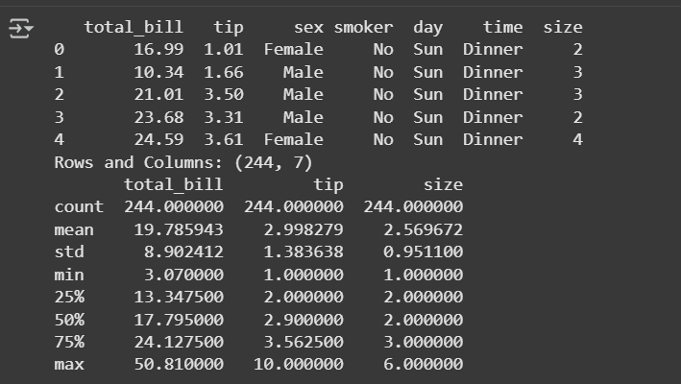
Q2.
Create a histogram with KDE for the tip column using Seaborn.
Add appropriate axis labels and a title: “Distribution of Tip Amounts”.
import matplotlib.pyplot as plt
sns.histplot(data=tips, x='tip', kde=True, color='skyblue')
plt.title('Distribution of Tip Amounts')
plt.xlabel('Tip ($)')
plt.ylabel('Count')
plt.show()
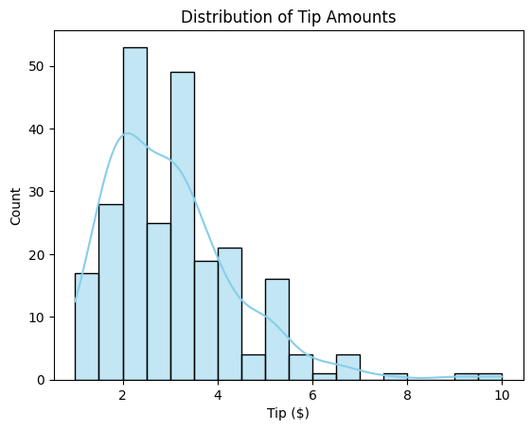
Q3.
Use Seaborn to draw a scatter plot showing the relationship between total_bill and tip,
colored (hue) by time and styled by sex.
Add a title and labels for both axes.
sns.scatterplot(data=tips, x='total_bill', y='tip', hue='time', style='sex',color='blue')
plt.title('Total Bill vs Tip by Time and Gender')
plt.xlabel('Total Bill ($)',fontsize=15)
plt.ylabel('Tip ($)',fontsize=15)
plt.grid('true',alpha=0.9)
plt.show()
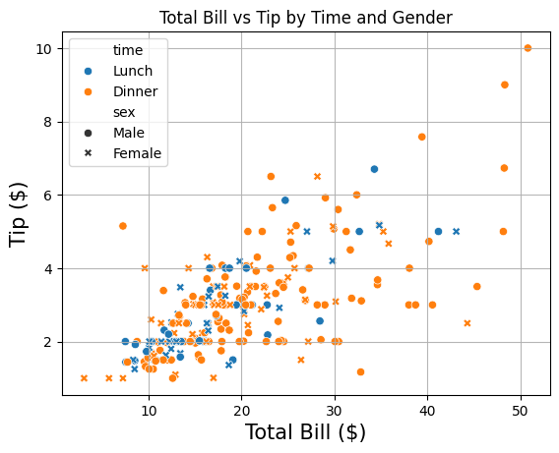
Q4.
Draw a box plot to compare the total_bill across different days,
separated by smoker status (hue='smoker').
Add a suitable title and axis labels.
sns.boxplot(data=tips, x='day', y='total_bill', hue='smoker')
plt.title('Total Bill by Day and Smoker Status')
plt.xlabel('Day')
plt.ylabel('Total Bill ($)')
plt.show()
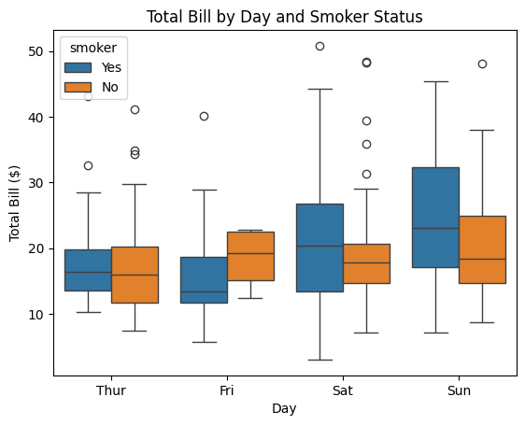
Q5.
Generate a correlation heatmap for the numeric columns (total_bill, tip, size)
with annotations and a color map of your choice.
Add a title: “Correlation Between Numerical Variables”.

corr = tips[['total_bill','tip','size']].corr()
sns.heatmap(corr, annot=True, cmap='coolwarm')
plt.title('Correlation Between Numerical Variables')
plt.show()
